
Koneru Lakshmaiah Education Foundation
(Deemed to be University estd. u/s. 3 of the UGC Act, 1956)
Off-Campus: Bachupally-Gandimaisamma Road, Bowrampet, Hyderabad, Telangana - 500 043. Phone No: 7815926816, www.klh.edu.in

STUDENT CASE STUDY EXECUTION REPORT
Department | FED
Subject | DSA-2
Academic Year | 1-111 Semester | 2025-26
Faculty Name | Mohd. Razia Alangir Banu
Student Name | P. Yaswanth Surya
Roll Number | 2520030581
Branch | CSE
Course Outcome | CO 4
Case Study Topic: Communication Routing using Shortest Path Algorithms
Work Done Summary:
In this case study, we implemented shortest path algorithms for communication routing in Internet networks.
Routers were represented as vertices and communication links as weighted edges. Dijkstra’s Algorithm was used to find the shortest path for packet transmission between source and destination routers. The system ensured efficient routing with minimum transmission cost and delay.
We also analyzed routing performance and compared different path options.

Implementation Details:
1 Represented routers and links using a weighted graph.
2 Implemented Dijkstra’s Algorithm for shortest path calculation.
3 Calculated minimum transmission cost between routers.
4 Identified optimal routing paths.
5 Compared alternate routing paths.
6 Evaluated network efficiency and packet delivery time.
• Evaluated network efficiency and packet delivery time.• Compared search performance with linear search methods. 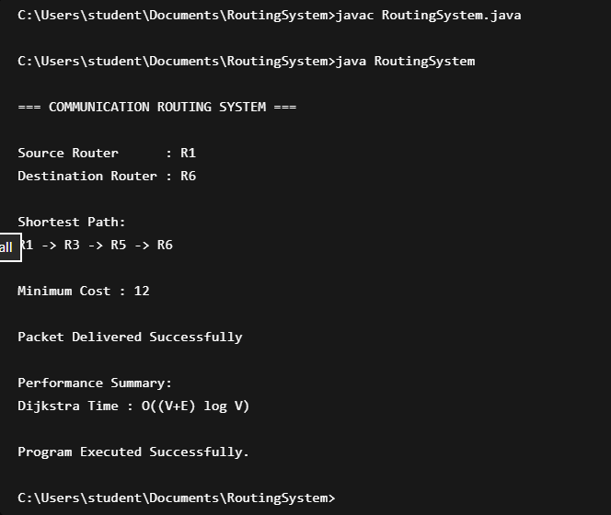

Result: Screenshots / Output
The shortest path algorithm successfully identified the optimal route for packet transmission.
Sample Output:
Source Router: R1
Destination Router: R6
Shortest Path:
R1 → R3 → R5 → R6
Minimum Cost = 12
Packet Delivered Successful

Time Complexity:
• Dijkstra's Algorithm: O((V + E) log V)

The routing system efficiently transmitted packets through the shortest available path, reducing network delay and communication cost.

GitHub Link: https://github.com/yaswanthsurya-99/DSA-2
Student Signature Faculty Signature

